

Plan van aanpak

Project: Barroc-IT



13 september 2016

Keanu janssen, Lennart bronner, Kobus haarhuis, tim schachtschabel

contents

backgrounds 2

goals 2

project assignments 2

project activities 2

project boundaries 3

products 3

quality 3

projectorganisatie 3

planning 4

kosten en baten 4

kosten 4

Baten 4

Risico’s 4

intern 4

Not meeting the deadline 5

Feasibility of contract 5

extern 6

Disease 6

Absence of project members by circumstances 6

Changing the problem or goal 6

# backgrounds

Barroc-IT is a software developement company that offers a wide array of different applications for education purposes. They already made programs like Evictus and StudentTracker. Those programs are used for administration. Barroc-IT wants a web application to make the customer administration go more smoothly, and edit automatically.

# goals

Making a project management system for better communication within the company.

# project assignments

It is about building an application that links the administration from the different sections. “Building an automatic link between the administrations” thus the client Mr. Van Bueren.

The client is Mr. Van Bueren, He will also , inter alia, to approve the PVA and evaluate the project. The contractor is the organisation Lionweb, the will design and implement the current project.

# project activities

This project includes the following project activities:

* Draft the PVA,
* A questionnaire preparing for the interview with the client,
* interviewing various departments,
* Wireframes sketches based on the needs and requirements of the customer,
* Create a planning,
* Making technical design of the web application,
* Making the web application,
* Prepare an acceptance test , carry out and execute customer,

# project boundaries

The project starts from 12-09-2016 and ends when the web application is delivered.

The project contractor will build the web application design in consultation with the customer using wireframes and full web application. The project contractor is not obliged to arrange for the delivery of images for the web application. The contractor is not obliged to provide a domain.

# products

The following products can get delivered to the customer :

* PVA,
* Schedule,
* Wireframes
* Functional design,
* Use-case diagrams,
* Use-case templates,
* Exported database file,
* Technical test,
* Functional test,
* Acceptance test,
* User’s Guide in english,
* De webapplicatie (hoofdproduct).

# quality

Consultation with the client is a very important part of the whole project. You're finally something for your client and it must meet the needs and requirements so we will therefore fall back throughout the project to the needs and requirements of the customer.

We remain at all times we can honestly something for whatever reason can not make it we will work with customers looking for an alternative / solution . Incidentally, we love a challenge so we will try to fulfill all wishes .

# projectorganisatie

The entire project is developed by L. Bronner, K. Haarhuis, T. Schachtschabel, K. Janssen commissioned by H. van Bueren.

# planning

Hieronder de algemene planning voor het project.

[..\20160913_barroc-it_algemene_planning.mpp](../20160913_barroc-it_algemene_planning.mpp)

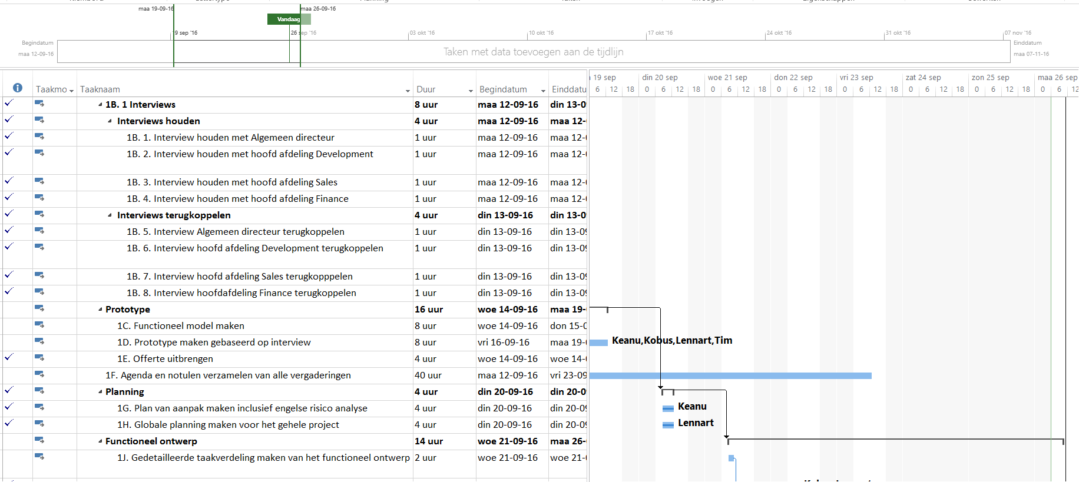

# kosten en baten

## kosten

N.V.T.

## Baten

N.V.T.

# Risico’s

## intern

Not meeting the deadline

If the schedule is not adhered to by all concerned by both the project and the steering committee , the risk that the deadline is not met by the project.

Feasibility of contract

It may happen that the research goals can not be achieved because of lack of funds in to achieve this within the planned timescale .

## extern

Disease

There is always a chance that someone gets sick within the steering committee and the project group. If the Avoid the entire steering committee or the entire project are long absent or sick, it must there be a consultation with the client Harry van Bueren.

Absence of project members by circumstances

There is always someone absent due to circumstances beyond the person can do nothing , concerned would already be able to start in such a case working until this person is there or else move appointment.

Changing the problem or goal

The opportunity for change during the project is small, but it can prevent these changes . In that case this will be communicated in due time to the steering committee and the project will be adapted in time . Also directly to the schedule to see whether this is feasible in the time remaining and it is checked whether there are alternatives to making this process in the most efficient manner.

